**Home page**   **Navigation Menu** **Log Your Workouts**

Click on whichever buttons Choose if you want to change Fill in the blanks of what

you want to use. settings, user information exercises you have done.

Or look at your history.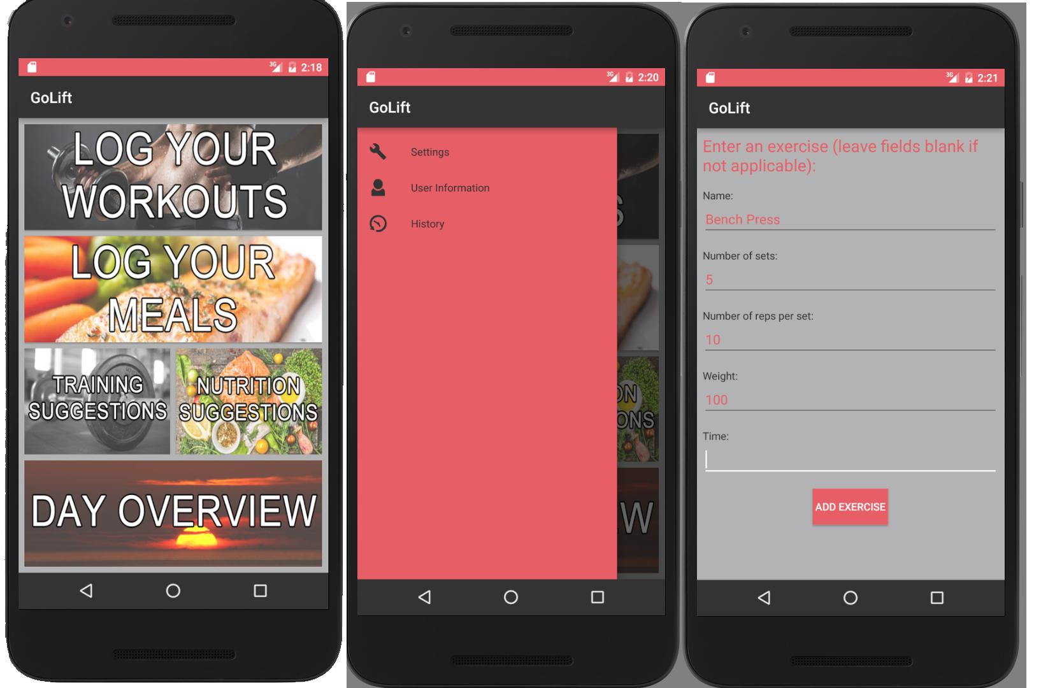

**Log Your Meals Day Overview Workout Suggestions**

Input the name, calories, You can see your You can see a general guideline

Protein, fat content, and nutrition summary and and example workout plan based

Carbohydrate content. exercise summary. on your specific body type.